**C1.3. PEITC and cranberry feeding** partially reverse the DSS-induced changes in fecal metabolome of WT C57BL/6 mice. A metabolomic platform for studying metabolic fates of phytochemicals and phytochemicals-induced metabolic changes through liquid chromatography mass spectroscopy (LC-MS)–based targeted and untargeted analysis has been established in Dr. Chi Chen (Co-PI)’s lab (91, 142, 143). Following a feeding trial containing control, DSS, DSS+PEITC, and DSS+cranberry treatments, the metabolomics profiles of fecal samples collected at week 2 and 6 of these 4 treatments were analyzed and the concentrations of short-chain fatty acids (SCFA), bile acids, and free amino acids were quantified. The results illustrated in a hierarchical clustering heatmap showed that DSS treatment dramatically altered the fecal metabolome while PEITC and cranberry feeding reversed some DSS-induced changes in fecal metabolites (Fig. 2A). For example, DSS decreased the concentrations of many amino acids (shown by glutamate, phenylalanine, and proline), but PEITC and cranberry cotreatments prevented these decreases (Fig. 2B-D). Furthermore, PEITC and cranberry cotreatments reversed the DSS-induced increases of secondary bile acids, mainly deoxycholic acid (DCA), lithocholic acid (LCA), and muricholic acid (MCA) (Fig. 2E-G). In contrast, PEITC and cranberry cotreatments had limited effects on the DSS-induced changes in SCFA (Fig. 2H-J). Overall, these preliminary data clearly indicated that PEITC and cranberry (rich in anthocyanins) are capable of modulating the metabolic responses to DSS treatment in the colorectal tract, potentially through their effects on the microbiome as shown in Fig. 1. In addition, the concentrations of fecal metabolites were compared between WT and Nrf2 KO mice in our preliminary study. Interestingly, compared to WT, KO mice had lower levels of amino acids (shown by glutamate, phenylalanine, and proline) and SCFA, and higher levels of secondary bile acids (shown by DCA, LCA, and MCA) than WT mice (Fig. 3A-I), which are similar to the metabolite profile of DSS-treated WT mice (Fig. 2).

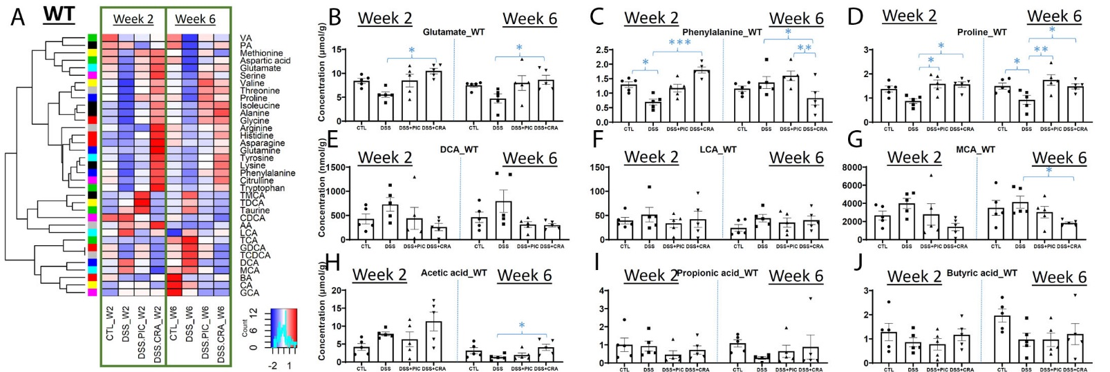

*Fig. 2.* Effects of DSS, PEITC and cranberry cotreatments on fecal metabolome of WT mice. Fecal samples collected at week 2 and 6 of 4 treatments, including control (CTL), DSS, DSS+PEITC (DSS+PIC), and DSS+cranberry (DSS+CRA), were analyzed by 4 LC-MS methods (143). The concentrations of amino acids, bile acids, and SCFA were quantified. (A) A heatmap on the distribution of amino acids, bile acids and SCFA in fecal samples from 4 treatments. (B-D) Concentrations of major amino acids, including glutamate, phenylalanine, and proline. (E-G) Concentrations of major bile acids, including DCA, LCA, and MCA. (H-J) Concentrations of major SCFA, including acetic acid (AA), propionic acid (PA), and butyric acid (BA).

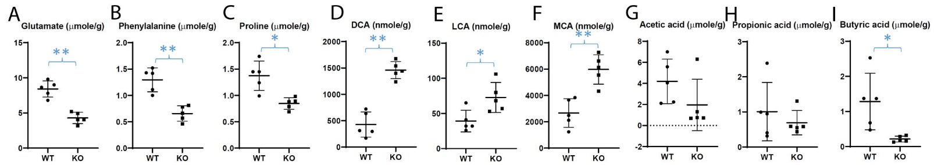

*Fig. 3.* Differences in fecal metabolite profile between WT and Nrf2-null (KO) mice. The concentrations of amino acids, bile acids, and SCFA were quantified in the fecal samples from untreated WT and KO mice (143). (A-C) Concentrations of glutamate, phenylalanine, and proline. (D-F) Concentrations of major bile acids. (G-I) Concentrations of major SCFA.